程序:
WBGC> GCSHUTDOWN
修改前需將機台WIN310(WIN320,330)機台停機時才可做RLOG版本修改
(可選擇是否將RLOG.SEQ做備份)
*TEL>BACKUP/IGNORE=INTER fil_data:rlog.seq;* RLOG.BCK/SAVE
(可選擇是否將rlog.seq 檔案做備份)
*TEL > PURGE fil_data:rlog.seq (將rlog.seq檔案purge掉)
(1).
到Manager Mode
(2).
TEL> exit(回首頁)
(3).
TEL> telasdsap(密碼)
(4).
TEL> set process/priv=all(開放權限,有些路徑才可進入)
(5).
TEL> DIR fil_data:rlog.seq/size(執行後會顯示RLOG此版本數目)
Directory DKB300:[WBGC.FIL.DATA]
RLOG.SEQ;32767 0
(6).
TEL> rename fil_data:rlog.seq;32767 fil_data:rlog.seq;1 (執行RLOG版本更新由:32767改為1)
TEL> DIR fil_data:rlog.seq/size (執行後會顯示RLOG此版本數目)
WBGC> GCSTARTUP (系統重啟)
(將G/C(WIN310,WIN320,WIN330) 做SYSTEMREBOOT or COMPUTER RESET重啟)

說明:
TEL> type purge_log.com (check rlog.seq 的版本及修改版本)
$ SET NOON (如遇ERROR會續RUN)
$ PURGE DKB300:[*...]*.LOG (執行PURGE DKB300內之*.LOG FILE)
$! DIR fil_data:rlog.seq/size (執行後會顯示RLOG此版本數目)
$! set process/priv=all
$! rename fil_data:rlog.seq;32767 fil_data:rlog.seq;1 (執行RLOG版本更新由:32767改為1)
$ EXIT

TEL> rename fil_data:rlog.seq;32767 fil_data:rlog.seq;1 (執行RLOG版本更新由:32767改為1)

WBGC> SHOW DEV D (檢查硬碟內FREE容量)

Device Device Error Volume Free Trans Mnt
Name Status Count Label Blocks Count Cnt
WIN330$DKA200: (SYSTEM) Mounted 0 SYSDSK 1201305 224 1
WIN330$DKA300: (PROGRAM) Mounted 0 DISK$SAP 942057 349 1

TEL> purge_log (執行PURGE DKB300內之*.LOG FILE)

TEL>@PURGE (執行PURGE purge/nolog fil_data:rlog.seq)

TEL> DIR fil_data:rlog.seq/size(執行後會顯示RLOG此版本數目)

Directory DKB300:[WBGC.FIL.DATA]

RLOG.SEQ;21505 0
RLOG.SEQ;21504 2027
RLOG.SEQ;21503 2029
RLOG.SEQ;21502 2028
RLOG.SEQ;21501 2027
RLOG.SEQ;21500 2029
RLOG.SEQ;21499 2028
RLOG.SEQ;21498 2027
RLOG.SEQ;21497 2028
RLOG.SEQ;21496 2028
RLOG.SEQ;21495 2028
RLOG.SEQ;21494 2027
RLOG.SEQ;21493 2028 (RLOG最新版本)

TEL>set process/priv=all (開放權限,有些路徑才可進入)

TEL>rename fil_data:rlog.seq;32767 fil_data:rlog.seq;1 (執行RLOG版本更新由:32767改為1)

範例:
TEL> dir RLOG.SEQ;32767/full
Directory DKB300:[WBGC.FIL.DATA]
RLOG.SEQ;32767 File ID: (1461,6234,0)
Size: 2036/2052 Owner: [400,1]
Created: 14-MAY-1999 03:59:31.78
Revised: 15-MAY-1999 17:19:39.20 (6)
Expires: <None specified>
Backup: <No backup recorded>
File organization: Sequential
File attributes: Allocation: 2052, Extend: 27, Global buffer count: 0
No version limit
Record format: Variable length, maximum 558 bytes
Record attributes: Carriage return carriage control
RMS attributes: None
Journaling enabled: None
File protection: System:RWED, Owner:RWED, Group:RWED, World:
Access Cntrl List: None

Total of 1 file, 2036/2052 blocks.
程序: PURGE DKA200 DISK FULL指令

(1).
TEL> set process/priv=all(開放權限,有些路徑才可進入)
(2). PURGE DKA200:[000000…]*.LOG
PURGE DKA200 DISK FULL指令(USERDISK FREE BLOCK:0 )
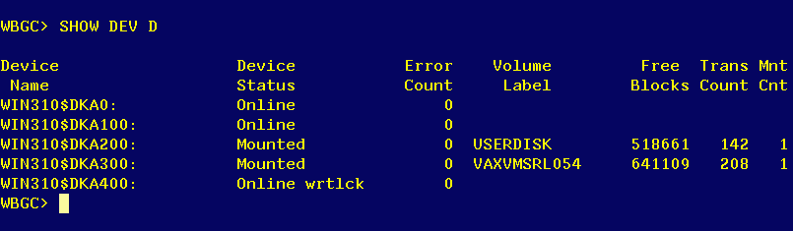

Purge.com有沒有Run可下指令 sh /que sys$batch檢查

- CHECK WIN310/320/330 DKA200 Purge.com
Purge.com有沒有Run可下指令 sh /que sys$batch檢查
